Hello,
Thank you for purchasing my file.
============================================
***** Please RATE this file! *****
Package Contain :
- Editable AI Files
- Editable EPS Files
- PNG Files
- Help File
Assets Contain :
- Background
- Window Panels
- Buttons
- Horse Character
- Sprites
- Preview Screens (Splash & Game play)
Font Uses :
- Bebas Neue : http://www.dafont.com/bebas-neue.font
Requirements : Adobe Illustrator CS or above.

Image bellow only for preview purpose
For your help
Here a little tips,
- TO CHANGE COLOR (BASIC)
- Step 1 : Pick your object/part you want to change with Direct Selection Tool (This case I choose Jersey Strip)
- Step 2 : Go to Color Panel and change whatever you want (I choose Black). Tadaaa..

Step 1
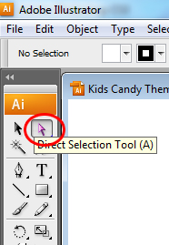

Step 2
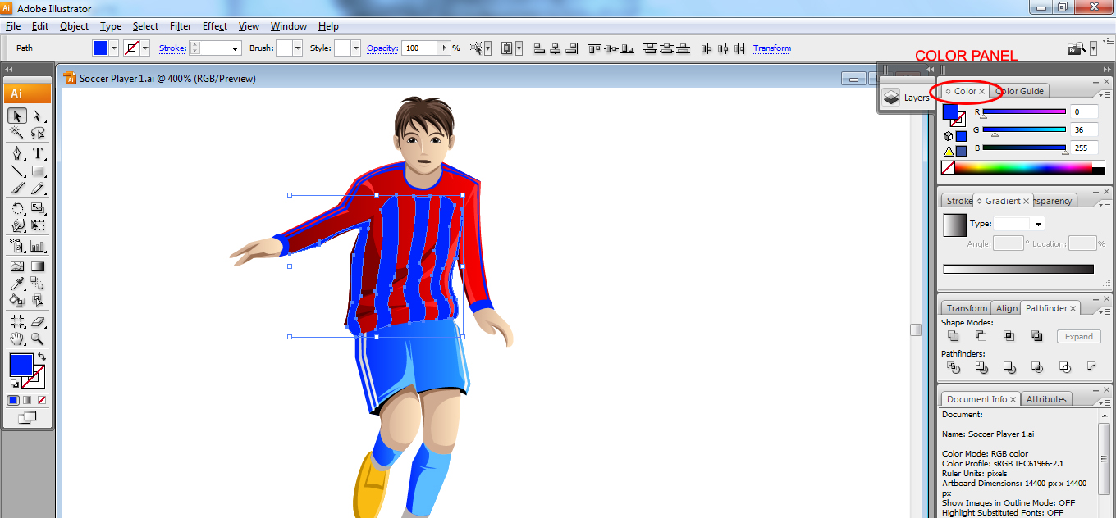

Step 2 (Result)
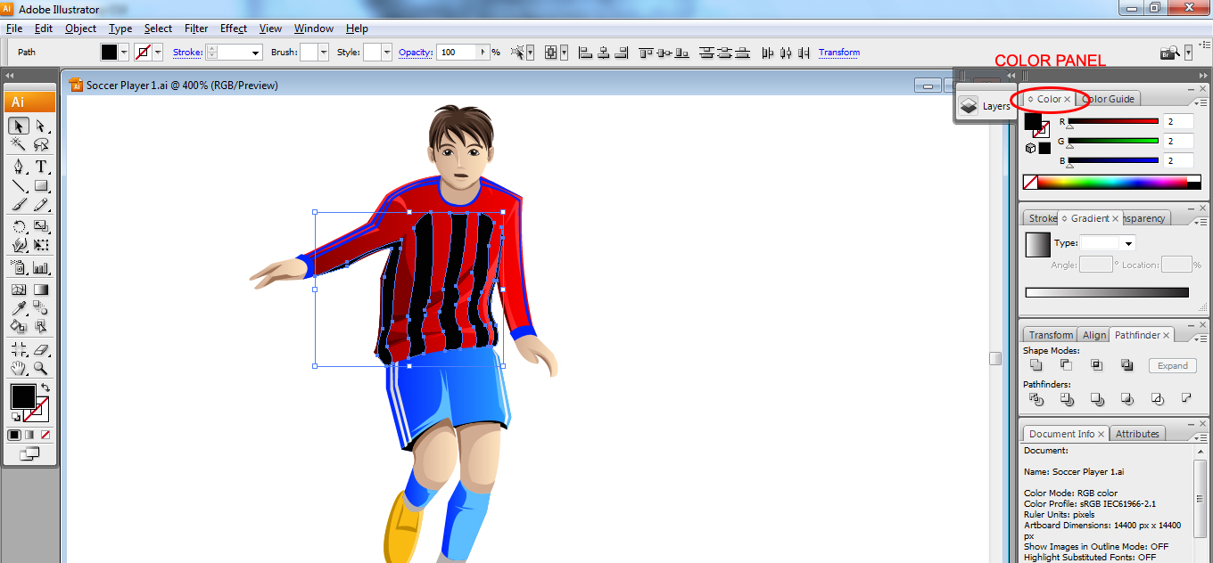

- TO CHANGE COLOR (GRADIENT)
- Step 1 : Pick your object/part you want to change with Direct Selection Tool (This case I choose Jersey Short)
- Step 2 : Go to Gradient Panel and change whatever you want (I choose Black). Tadaaa..

Step 1

Step 2
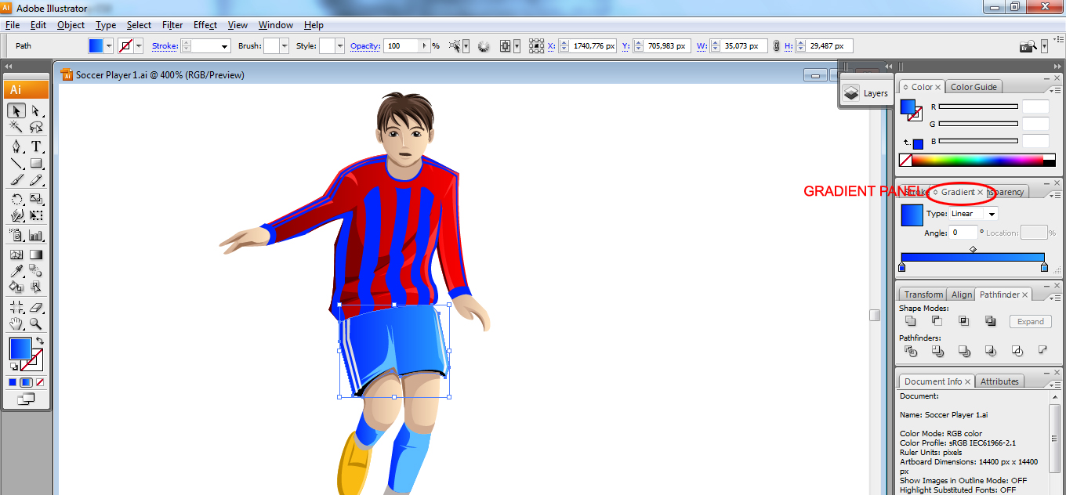
Step 2 (Result)
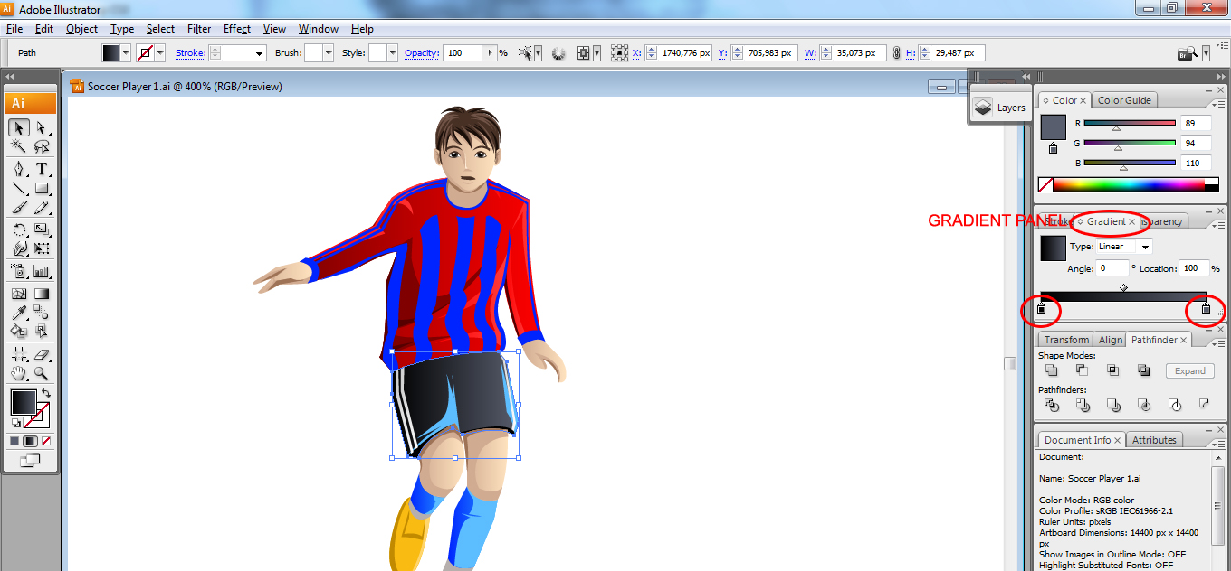

If you need help for more, please contact me on my profile page. I’ll try to help you all I can
Best wishes,
Erkou

